BIOLOGY 4605/7220 Statistical Analysis in Biology and Environmental Science FALL 2022

Version: 5 Oct

**Lectures:** Mon Wed Fri 12 PM ED 3034B

**Labs:** Tue 2-5 or 6-9 PM Online + drop in help

**Instructors:** David Schneider Office (202 Elizabeth Ave) Tel 864-8393

[a84dcs@mun.ca](mailto:a84dcs@mun.ca) Hours - after class or by appointment (CSF4220)

Amy Hurford Office (CSF 4338) Tel 864-8301

ahurford@mun.ca Hours -

Teaching Assistant: Brendan Carswell bmcarswell@mun.ca

**Course Summary**. The goal of this course is for you to learn a model based approach to the statistical analysis of research data. Skill and confidence come with practice, so assignments and quizzes will be short and frequent. Lecture material will emphasize principles of good quantitative analysis, illustrated by complete examples. Laboratories will cover the computational aspects of problem solving, with a package of the student’s choice.

**Goals**

1. Principles of good analysis.

2. Skill in application.

3. Capacity for self-instruction.

4. Confer with statistician.

5. Develop critical capacity.

6. Evaluate quantitative presentations.

**Pre-Requisite:** 1 course in statistics. 2/3 of students in 2017 considered this unnecessary.

Exams and quizzes are open book, emphasizing use of tools, rather than to memorizing formulas.

Graduate students (Biology 7220) will be required to prepare a written report on the analysis of a set of data of interest to the student. The topic will be decided during a conference early during the term, then discussed during tutorial sessions. The report will constitute 30% of the final mark.

If you are unable to complete evaluated work due to acceptable cause submit a written request stating your name, the date and name of work, and reason for non-completion.

All course material is at https://davidcschneider.github.io/StatisticalScience/

**Required material:** Lecture Notes in Statistical Science

Laboratories in Statistical Science

**Additional material:** Review Questions in Statistical Science

A calculator is required for quizzes, exams, and Lab 2. The calculator (which can be an app on a portable device) does not require statistical functions but does require *yx* and *ex* functions.

Labs and assignments are due in pdf format on the date stated in the syllabus. Work will be returned to students within a week (usually the next lecture after it is due}.

Late work will be penalized at 5% off per day (excluding weekends).

Lab 1 is a group project that requires attendance for successful completion. Labs 2 and 9a are group projects for which attendance is recommended.

COVID disruption. In the event of a rapid rise in COVID19 cases, this course will shift to online for labs and lectures, as delivered in the Fall 2020 term.

For latest information and updates see: <https://www.mun.ca/covid19/>

**About quizzes/short assignments.** These cover lecture material since the previous quiz. Midterm and final exams will have the same format as quizzes. Examples of quizzes are posted on the course website. In class quizzes are easier to do on paper than electronically; please submit them electronically to BrightSpace. Short assessments (SA) are quizzes due by the end of the day.

**About labs and assignments**. Working together is encouraged in all labs and assignments. However, each person is responsible for preparing their *own* written report (don’t share write-ups). Obvious duplicates will be considered misconduct (see below). Please submit all work on BrightSpace.

**About statistical packages**. Labs 3, 5, and 6 can be completed in a statistical package or in a spreadsheet using functions and data analysis tools. Labs 3-9 can be completed in any statistical package with a general linear model (GLM) routine. Lab 10 can be completed in any package with a logistic regression routine, or with a generalized linear model (GzLM) routine.

Packages that lack a GLM routine and a logistic regression routine are superficially attractive but lack any value in learning principles and best practice in statistical analysis.

Statistical packages consist of line code (you type the command) and a GUI– a graphics user interface (mouse clicks to set up the analytic model).

This course uses RStudio but it does not require any particular package. One of the instructors (DCS) can help you with any of the following.

SPSS. Easily learned GUI, line code not suitable for archiving, randomization not possible.

Minitab. Easily learned GUI. Line code adequate for GLM and simple calculations.

JMP. GUI for SAS code.

SAS. Relatively easy line code. Gold standard for statistical analysis. Expensive license.

RStudio. Open source freeware for editing and executing R code. [https://www.rstudio.com](http://www.rstudio.com/)/

R. Freeware for statistical computing and graphics. Line code more opaque than SAS or Minitab. R has overtaken SAS in academic settings because it has no licensing fee. The hidden cost is the learning curve. The course website has Rcode for all the labs.

**Printing computer output.** Please do not print the sometimes verbose files produced by statistical packages. Instead, copy and paste the appropriate sections of output into your lab report or assignment. Note that you will have to use a non-scalable font (such as courier) to print or display numerical output (ANOVA tables, *etc.*) without distortion.

**Assignments**. See schedule (page 4) for due dates.

A1. Quantities

In the library or on line, find a journal reporting research results. Open the journal to an article, and list the first defined physical or biological quantity you encounter (if you must move to the next article, then so be it). State the journal name, volume, and page number. For this quantity, provide complete details for each of the 5 components of the quantity: name, symbol, typical value, units, and procedural statement. If a component is not present then state ‘not present.’

Find 3 more quantities; complete the following 8 point check list for all 4 quantities.

Journal name, volume, and page number

name of quantity in words. Present?

If so, name is

symbol Present in article ? number of values N = or cannot be determined procedural statement Present ? Reproducible by another investigator ?

type of measurement scale (nominal, ordinal, interval, ratio)

If ratio scale: units =

(4 due in all)

**Assignments** A2-A5 These require graphs and summary statistics from a text book or published literature. To find examples on a topic of interest to you try Google Scholar. Publications with suitable examples are listed on the course website.

A2. Data Equations.. In the published literature find a graph where a regression equation has been displayed. A list of such publications can be found on the course website: [https://github.com/DavidCSchneider/StatisticalScience/tree/main/Data](http://www.mun.ca/biology/schneider/b4605/Data/RefswithRegressionEquations.pdf)

State the source publication (request bonus point for an example not on the course website). Write the equation, write the name of each symbol or parameter value, and give its units. Immediately below the equation (symbolic form) display a data equation for each of 3 different values of the explanatory (X) variable.

A3. Hypothesis testing. Find, in the published literature, two mean values with associated standard deviations and sample size.

1. Report the 6 values with full citation of source of the published data.

2. Compute the t-statistic using the appropriate formula from Ch7.3. State which formula you used and why. Use the 10 step generic recipe for decision making with statistics (Ch7.3, Table 7.1) to declare a decision about the two means.

A4. Confidence intervals. For the same data used in A3, compute the confidence limits for each mean. Report all 6 values (means, sd, n), the source of the numbers, and both confidence limits. Use the generic recipe for confidence limits (Ch7.5, Table 7.5a).

To obtain critical *t*-values for confidence intervals, use commands you learned in Lab 3.

A5. Correlation. Find, in the published literature, a table of data that you consider appropriate for correlation. Enter the data into a spreadsheet or statistical package. Compute the mean and variance for each variable. Compute the correlation coefficient. State the source of the data (with full citation), why correlation is appropriate, then display the data (label each column), each mean and variance, and the correlation coefficient. Show calculation of the likelihood ratio from the correlation coefficient. State whether inference to a population is possible and defend your argument for or against calculating a p-value to make the inference.

**TABS** Teaching assessment by students.

Course evaluation questionnaires are of use to instructors in several aspects of teaching, especially delivery. Questionnaires at the end of the course are of little use to students, as it is too late for corrective action. No-name questionnaires and polls during the course have been a regular part of these two courses since 1994. They are typically short, a few minutes before the end of a lecture period. Short summaries of the results are usually delivered orally in class.

* * *

*Memorial University of Newfoundland is committed to supporting inclusive education based on the principles of equity, accessibility and collaboration. Accommodations are provided within the scope of the University Policies for the Accommodations for Students with Disabilities (*[*www.mun.ca/policy/site/policy.php?id=239*](http://www.mun.ca/policy/site/policy.php?id=239)*). Students who may need an academic accommodation are asked to initiate the request with the Glenn Roy Blundon Centre at the earliest opportunity (*[*www.mun.ca/blundon*](http://www.mun.ca/blundon)*).*

Students are expected to adhere to those principles which constitute proper academic conduct. A student has the responsibility to know which actions, as described under Academic Offences in the University Regulations, could be construed as dishonest or improper. Students found guilty of an academic offence may be subject to a number of penalties commensurate with the offence including reprimand, reduction of grade, probation, suspension or expulsion from the University. For more information regarding this policy, students should refer to the University Regulations for Academic Misconduct (Section 6.12) in the University Calendar.

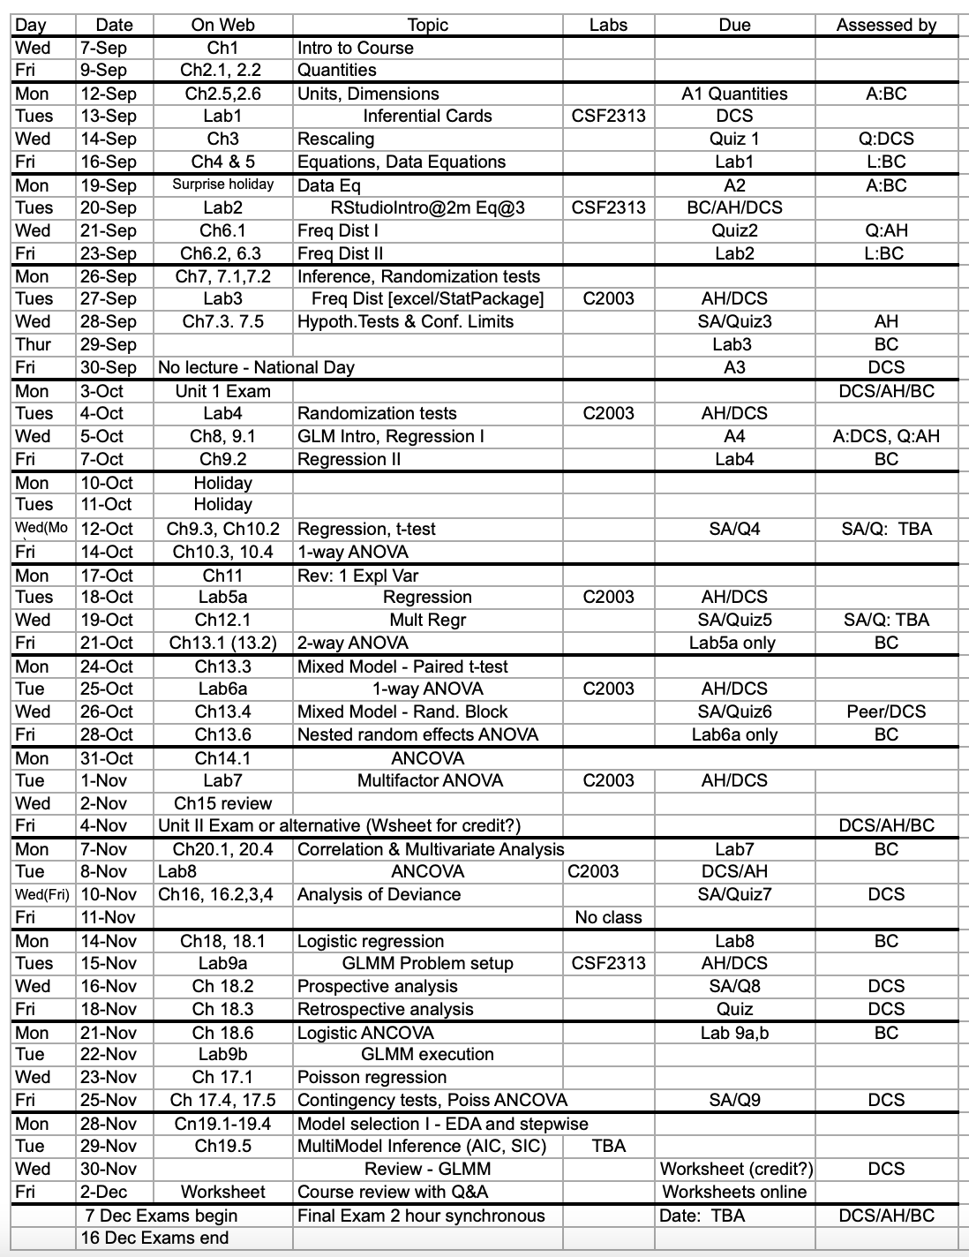

First Day Survey (No names please) Biology 4605/7220 Fall 2022

The purpose of this survey is to gather information about student background, including experience and familiarity with online submission of activities (assignments, labs, quizzes, exams) listed on the first page. The information will be used for planning course delivery.

1. To be completed in class. If not, please print it from the website, fill it out in pen, take a photo, and mail it to David.Schneider@mun.ca.

2. Which course are you taking? Circle or highlight one. B4605 B7220

Grad students: list department or program _____________________________

Honors students: List program __________ and topic ________________________

3. Using a calculator or spreadsheet can you calculate 54  Y / N ? e0.75 Y / N

4. Have you ever used the R-Studio statistical package ? Y / N

List other statistical packages you have used. ______ _______ _______ _______

5. Have you ever used one of the functions in a spreadsheet ? Y / N

6. Do you have a laptop or touchscreen device (larger than a phone) that can be used in a classroom setting? Y / N

7. How long has it been since you used logarithms ? ___________

8. The variable Y has three values, Y = [ 9 6 3 ] What is the mean value of Y ?

9. How many online courses have you taken? Circle or highlight one: None Several Too many

B7220 only: Which platforms have you used? WebEx Y/N Zoom Y/N Other _____ ____

B7220 only: How many courses have you taken with the

Brightspace / D2L Learning Management System (LMS) at MUN? None Several Many

10a. How many university courses in mathematics? _______In statistics? ______

10b. Have you already learned how to do an ANCOVA in a previous course? Y / N

11. How many university courses where you have collected data? _______

12. How many courses where you have analyzed data? ________

13. List (opposite side) any non-classroom experience with quantitative techniques, including any data sets you have collected.

14. Describe what you hope to learn during this course and how it relates to your academic program.